W301A-How to setup the AP Repeater mode

Product line: Wireless Question category: Function configurations

Q: Why do we want to configure W301A to work as repeater mode?
A: Repeater Mode can repeat and amplify wireless signals to extend wireless network coverage. In this mode, wireless clients and wired clients are allowed to connect.

The Connection Topology is as below:

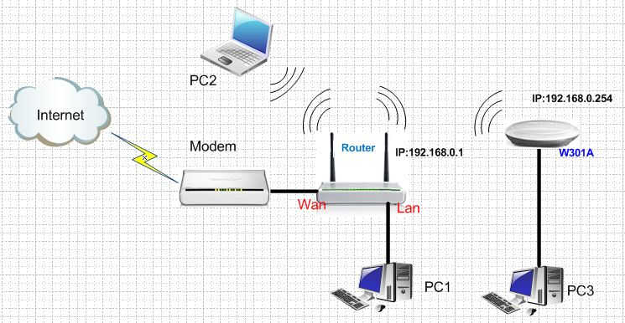

The steps are as below:

Settings in your wireless Router(take W306R for example)
1．Connect your computer with the LAN port of W306R by an Ethernet cable, then login to the home page of W306R through typing http://192.168.0.1 in the address bar of a web browser, and a pop-up will appear and require you to input a username and password, the default username and password are both admin.
2．Then click WLAN setting→Basic settings to change the SSID and choose channel 6. And then Click Apply to save the settings.
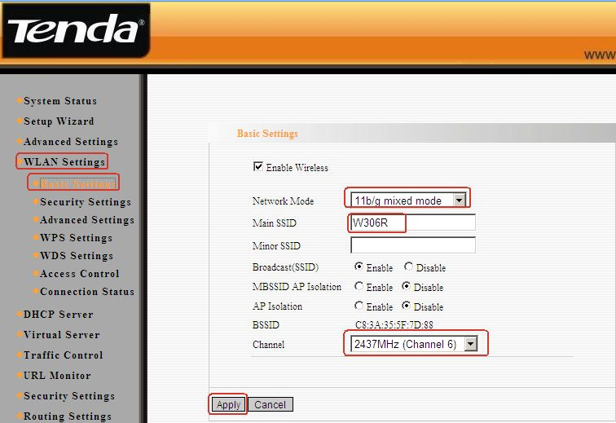3. Click WLAN setting→ security settings to choose WPA-personal as security mode and choose AES as WPA Algorithms, please type your password for wireless network in the blank of Pass Phrase. Don’t forget to click Apply to save.

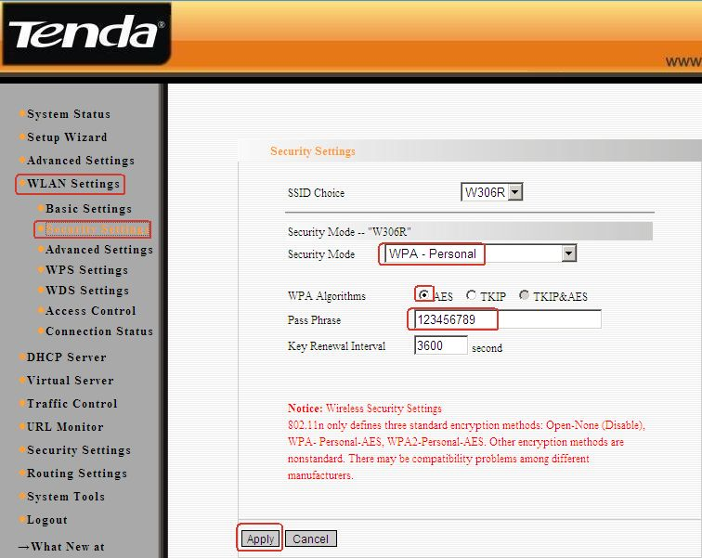
4. Then click WLAN setting→ WPS settings to choose Disable to disable the WPS, click Apply to save the setting.
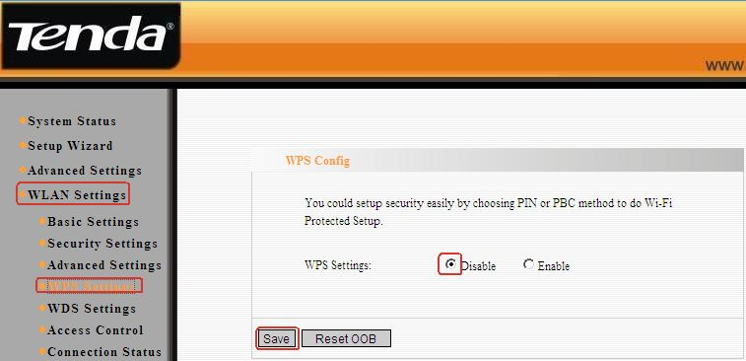

Settings in the W301A
1. Login to the homepage of W301A.
2. After successful logging, please click Setup Wizard, and choose bridge (WDS) as the wireless working mode. And then click Next.
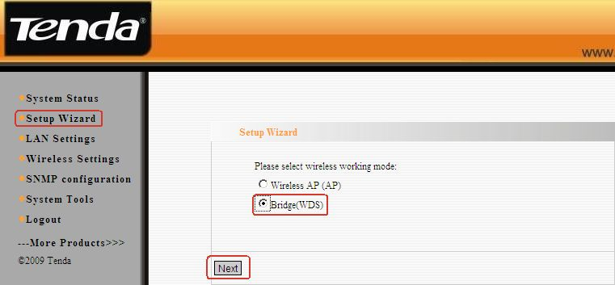
3. In the next page, you can change the SSID(your wireless network’s name), select channel 6(the same as uplink),choose WDS AP Repeater as the WDS mode, and then click Open Scan, find and tick your uplink’s signal.After click OK you can find the MAC address added in the blank of AP MAC, then click Next.
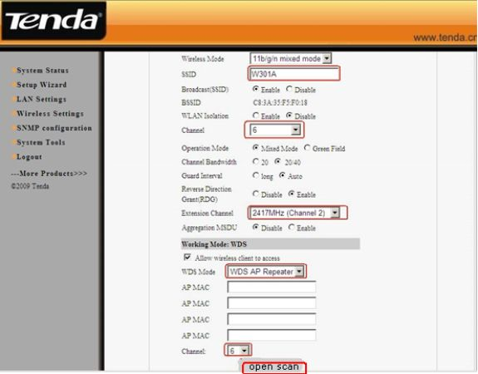

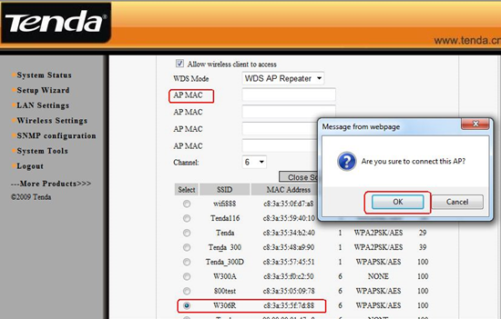
4. In the Security settings, disable the WDS-security. And then click Next.
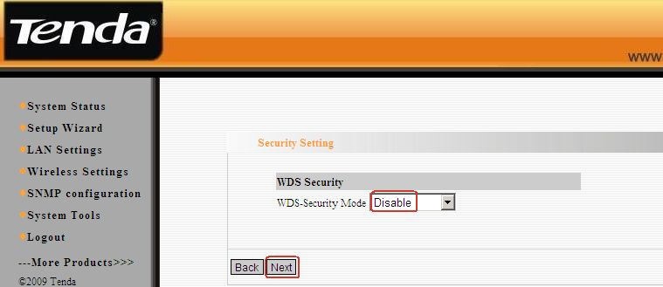
5. In the next menu, click Save to save your settings.
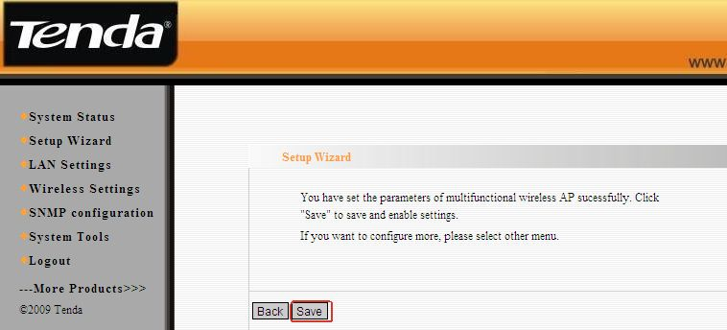
6. Go back to your uplink router’s management page, and click WLAN setting→WDS settings. Please choose Repeater Mode as WDS Mode, then click Open Scan, find and tick the signal of W301A. After click OK you can find the MAC address added in the blank of AP MAC. Click on Apply to save, and then the router will reboot.
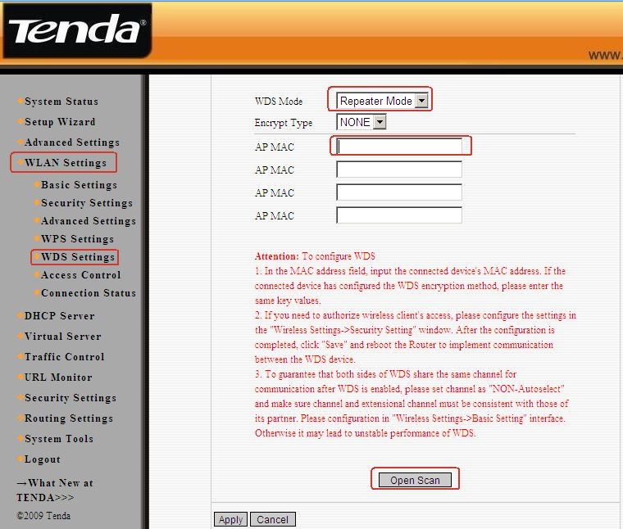

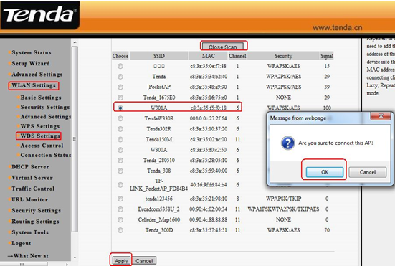
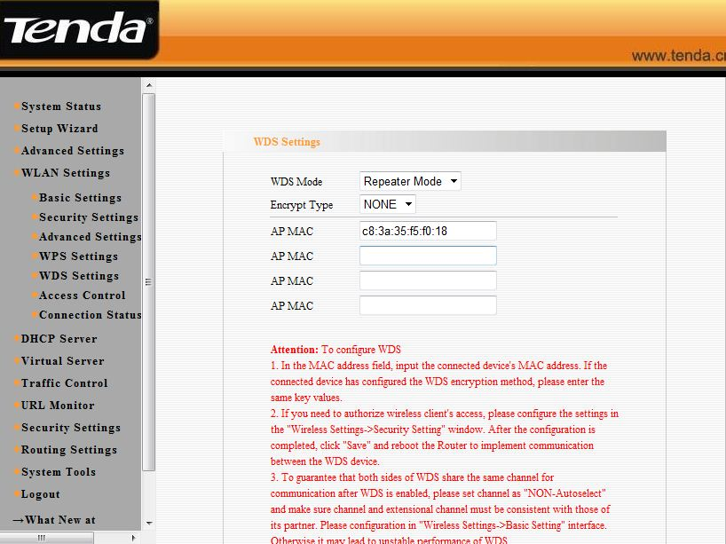

7, then the client can connect to W301A by an Ethernet cable and can get an IP address from the uplink wireless router.

